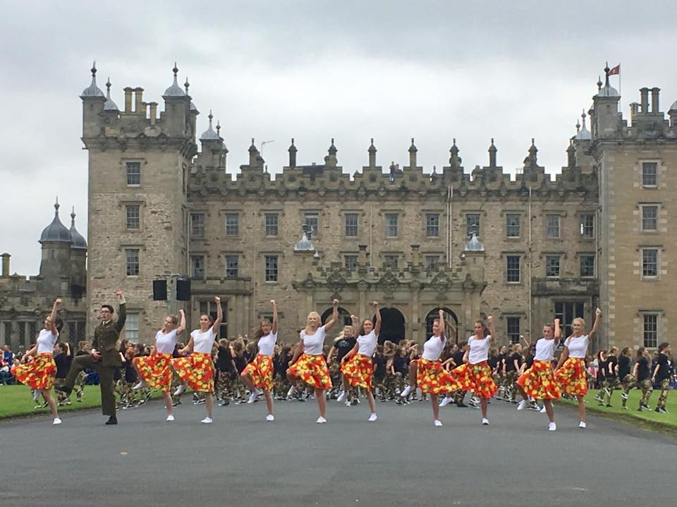
RECRUITING NOW!
MASS DANCE CAST
FLOORS CASTLE MASSED PIPE BANDS DAY
SUNDAY 26TH Aug 2018

After the success of our performance at Floors Castle last year, I am delighted to have been invited back to perform a segment at this year’s Massed Pipe Bands day again. This year’s event will celebrate and mark 2018 being 100 years since the end of WW1. I now have a big creative project on my hands in trying to put together a 20 minute segment based on this theme, whilst making it different to last year’s piece. I will be recruiting a large mass cast of around 120 dancers which will be made up of three sections. The groups, outlined below, will have different levels of commitment so please only sign up for the group that matches age wise AND fits in with your summer. Ages are based on CURRENT school year.
MASS CAST P4-S6 | FOCUSSED CHOREOGRAPHY P6-S2 & S3+
Some of the choreography for this group will be outlined in class from March-June. They then ‘mass up’ during summer rehearsals. Floor patterns and formations in HUGE groups compared to their normal classes of 20.  Despite the choreography being already covered, things may change as I put the piece together and formation stuff is hard, especially for younger dancers so summer rehearsals are required. These are listed below. Dancers should check with Michelle to ok any absences before signing up.  All mass cast will need to supply costume:  - Plain black leggings  - Plain black hoodie  - Red t-shirt  - Black trainers  REHERASALS:  Wednesdays 18th Jul, 25th Jul, 1st Aug, 8th Aug, 15th Aug  10.30-12.00AM  Kelso High School Games Hall  £15.00 | This choreography will be brand new. Only dancers who are keen to do extra training should sign up for this and numbers will be capped.  Focussed group dancers will be expected to be at all rehearsals. Anyone keen to be in this group but unable to do all should chat to Michelle before registering to check whether it’s ok.  All focussed cast will be required to supply costume depending on character given. These will be issued once registration has been completed (as costume depend on numbers…)  P6-S2 rehearsal is scheduled for 1h30 but this may be split into two groups  REHERASALS:  Wednesdays 18th July, 25th July, 1st Aug, 8th Aug, 15th Aug  P6-S2 9.00-10.30AM (KHS) Plus mass cast 10.30-12.00  S3+ 6.00-7.00PM (Studio)  £25.00

ADDITIONAL COMPULSORY DATES:
On site Rehearsal Sat 25th Aug (9am-10am), Performance Sun 26th Aug (all afternoon)
WOULD YOU LIKE TO BE IN THE CAST?! Booking is at mdsd.class4kids.co.uk from 1st April. Registration will end when numbers reach cap (on focussed groups) or on 6th May. Payment should be made at time of registration, online. Reminder: please chat to Michelle prior to boking of you have holidays already booked. This is not a casual event, we must work together to put together a full set and this only happens with commitment to rehearsals, please respect this. Michelle x

